**Housing Section**

A screenshot of a social media post

Description generated with very high confidence

**Housing Home Page:**

* By clicking ‘Manage Housing Type’ admin will be redirected to manage housing type page.
* By clicking ‘Manage Housing’ admin will be redirected to manage housing page.
* By clicking ‘Search Housing User’ user will be able to search user.

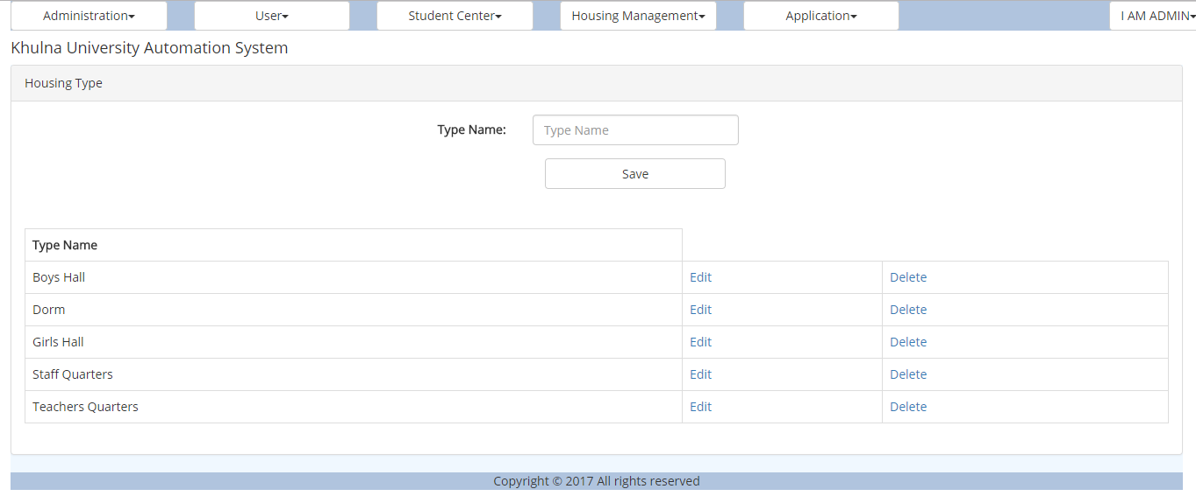

**Housing Type Page:**

* In this page a new type of housing can be created.
* Admin can edit and delete housing type.

A screenshot of a social media post

Description generated with very high confidence

**Manage Housing:**

* In this page admin will be able to create a new page entering the name, type, floors and no. of rooms.
* Clicking the housing name user will be redirected to detais page.
* Admin can add details of the housing clicking ‘Details Add’.
* Admin can edit and delete housing.

A screenshot of a social media post

Description generated with very high confidence

**Housing Room:**

* Admin can and delete room from here.
* By clicking room no will be able to see details of the room.

A screenshot of a social media post

Description generated with very high confidence

**Housing Room Assign:**

* User can be assigned and remove in a specific room.

A screenshot of a social media post

Description generated with very high confidence

**Add Housing Details:**

* Admin can add details and manage the details here.

A screenshot of a social media post

Description generated with very high confidence

**User Search:**

* User can be searched filling the criteria.

**Application Section**

A screenshot of a social media post

Description generated with very high confidence

**Application Home:**

* This is home of application.
* Clicking ‘Manage Application’ admin can see the applications
* Admin can create ‘Application Template’.
* User can choose application format.

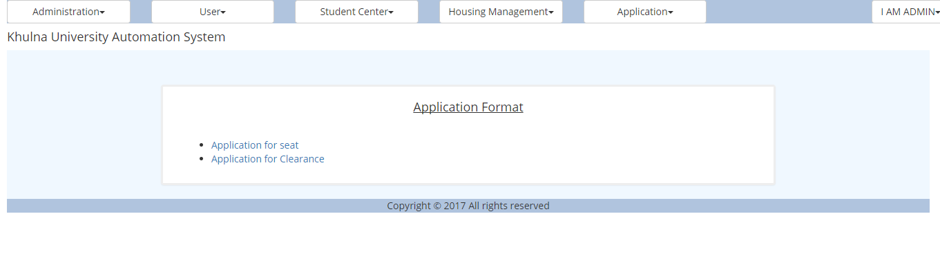

**Application Format:**

* User can select application format here.

A screenshot of a cell phone

Description generated with very high confidence

**Application Apply:**

* User can edit the given template from here.
* Apply to the department desired.

A screenshot of a cell phone

Description generated with very high confidence

**Application Manage:**

* Admin can see the submitted application here.